HANDS-ON EVIDENCE WRITEUP 04 / 04

Snort: SYN Scan Detection mapped to T1046
  - Objective → test → observed result → SOC interpretation

Objective
Create an Nmap SYN-scan detector with metadata referencing MITRE ATT&CK T1046: Network Service Discovery.

Method
Added local SID 1000004 with flags:S and threshold count 20 within 1 second; ran Kali nmap -sS -T4 -p 1-1000 against Ubuntu 192.168.56.101.

Evidence
Local rule file, Snort configuration validation and alert screenshot demonstrate test of the thresholded SYN signature.

Important lab configuration
EXTERNAL_NET was set to any rather than !$HOME_NET because the test Kali VM 192.168.56.102 sits within the same 192.168.56.0/24 HOME_NET; this broadens matching and may increase false positives.

Limitation
Rule detects a burst of SYN packets, not proof that Nmap was the software used. Attack mapping is analyst-added context; it does not independently establish malicious intent.
sudo snort -T -i enp0s8 -c /etc/snort/snort.conf
sudo snort -A console -q -c /etc/snort/snort.conf -i enp0s8
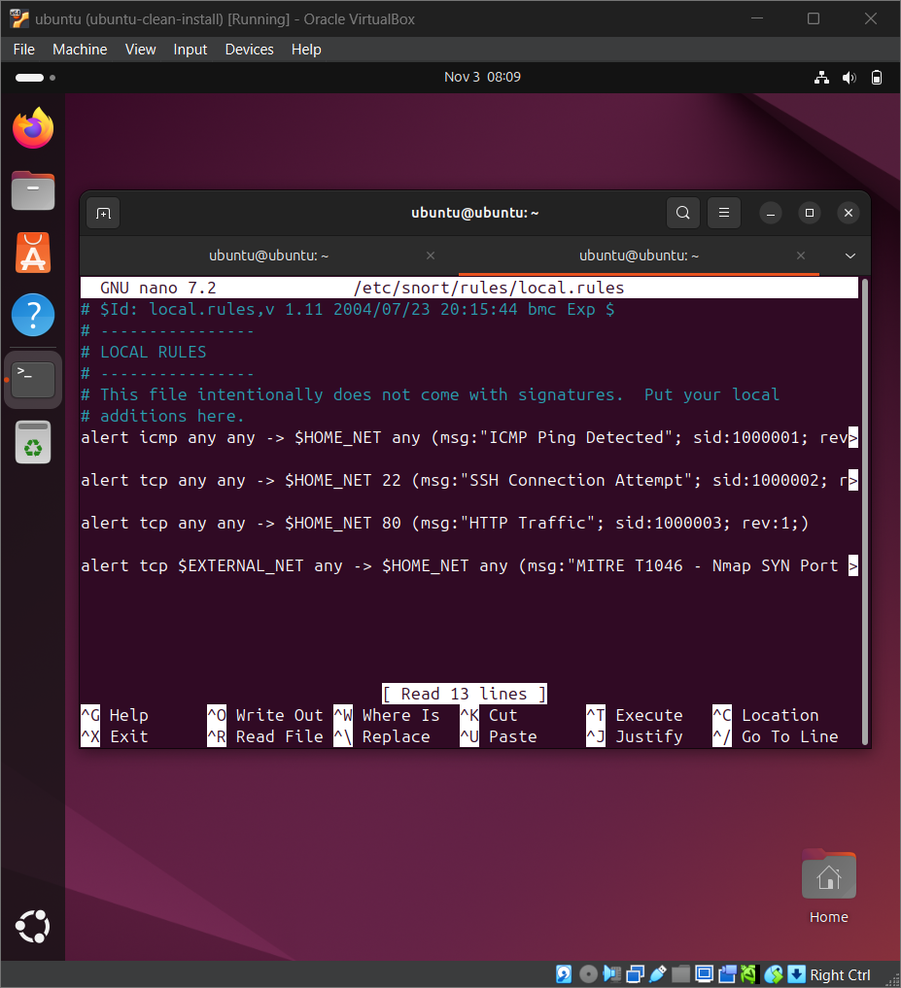
10 Snort All 4 Rules
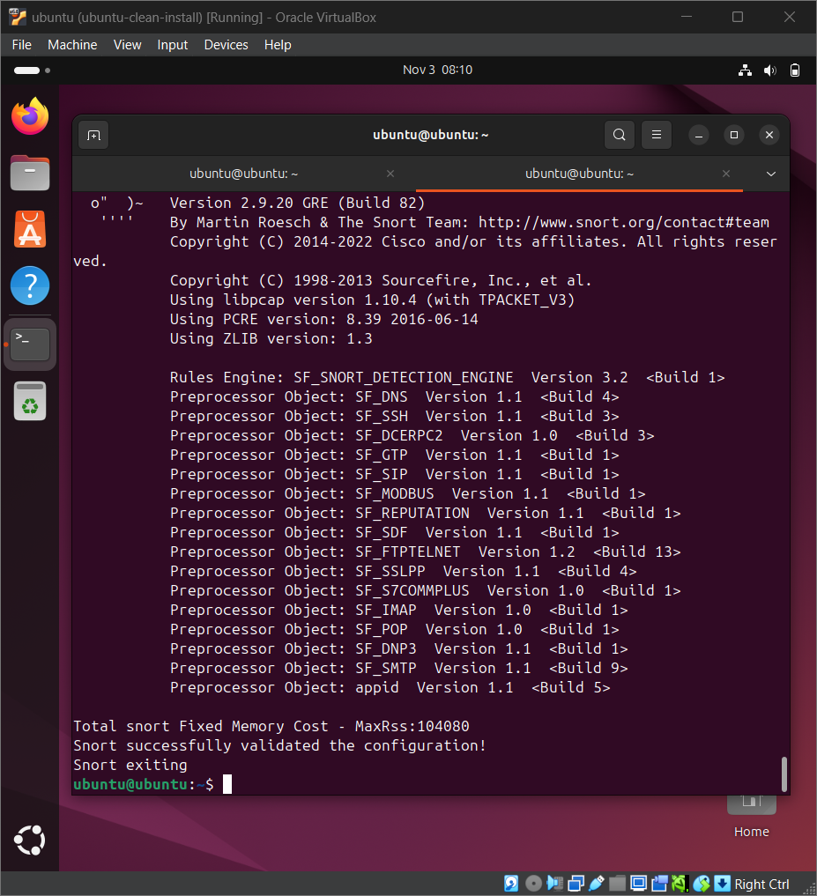
11 Snort 4 Rules Validation
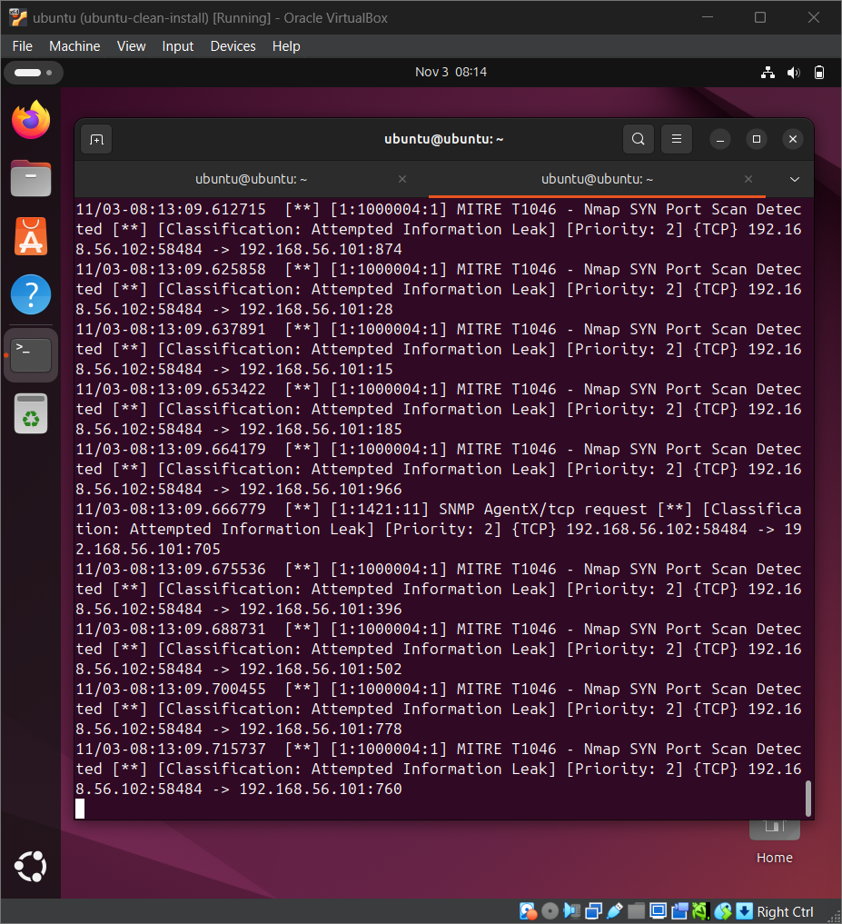
12 Snort MITRE T1046 Nmap Alert

